**WEB PROGRAMMING BCSE203E**

**MINI PROJECT**

**GROUP MEMBERS-**

**PRIYAL CHAMARIA (23BCE2100)**

**SANKALP SHARMA (23BCT0245)**

Q.Design a web page to create an institution infrastructure catalogue system. It should summarise auditorium, seminar hall, various labs, various cells (TBI/Placement Cell and so on) with its venue detail, photograph, workshop and so on. You may consider TT, CDMM,GDN, SMV for the same. The website must have professional design and structure. If the backend is required, use MySQL.

**GITHUB LINK:**

1. **Open the website and you can also click on facilities or about to navigate down.**

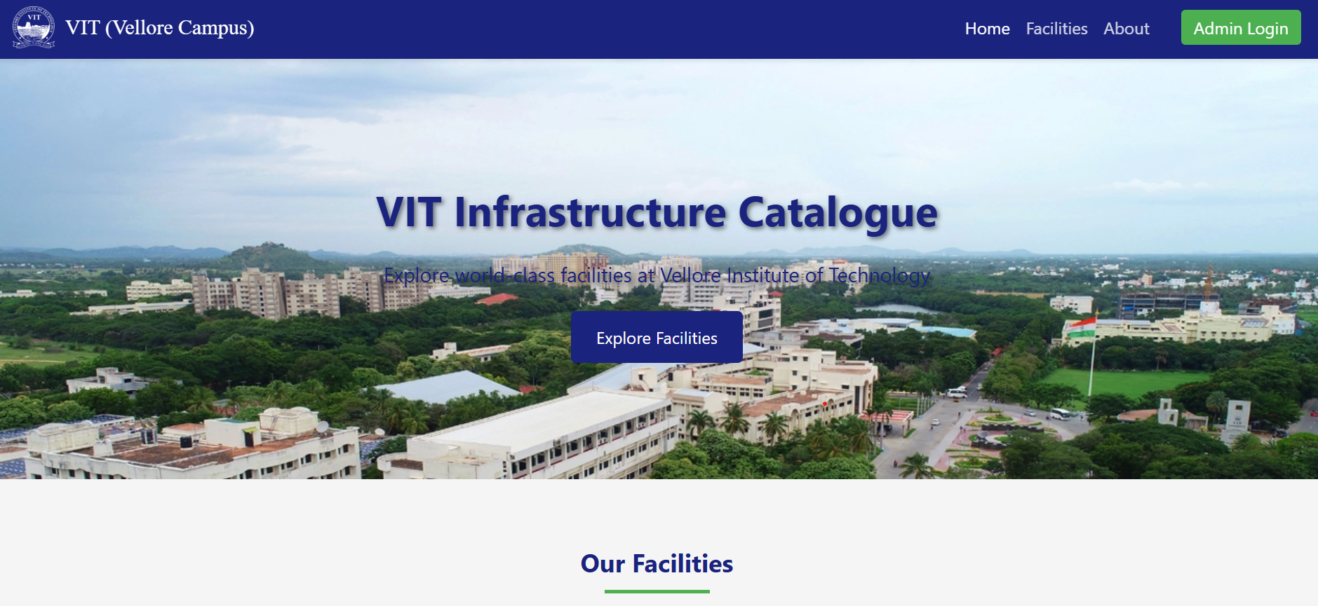

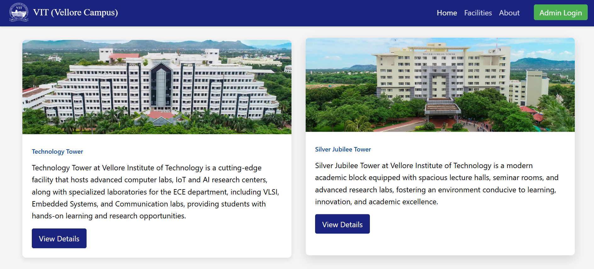

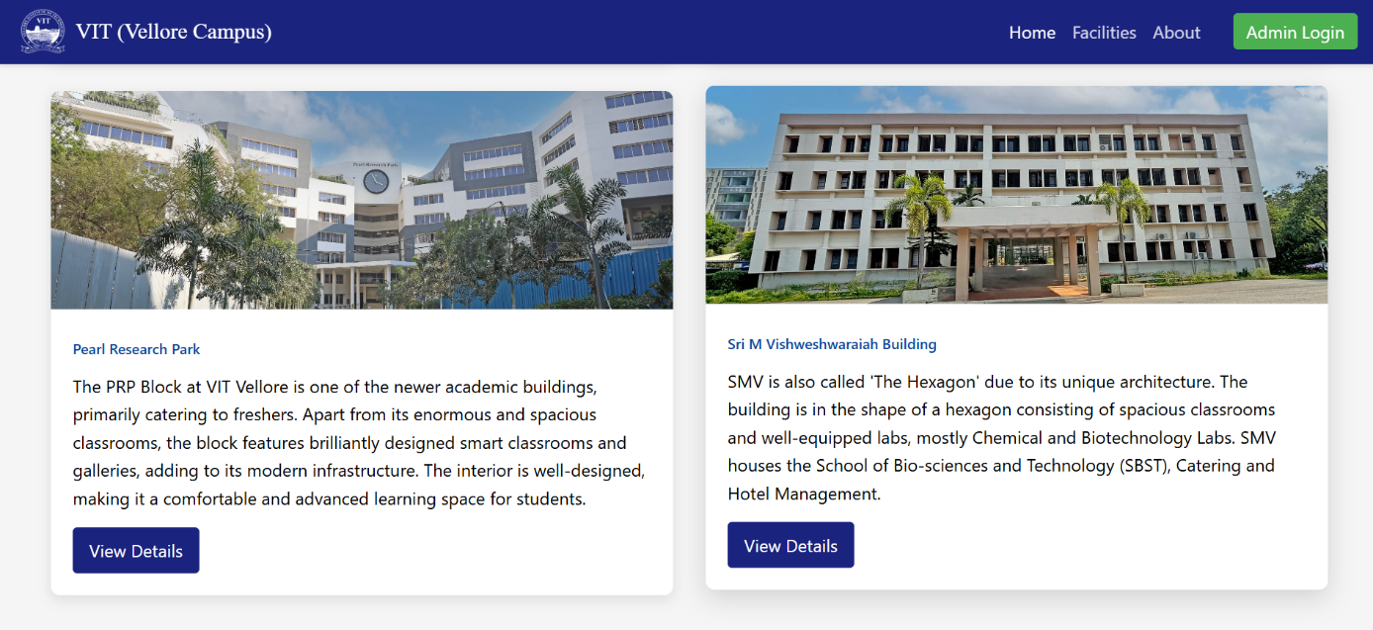

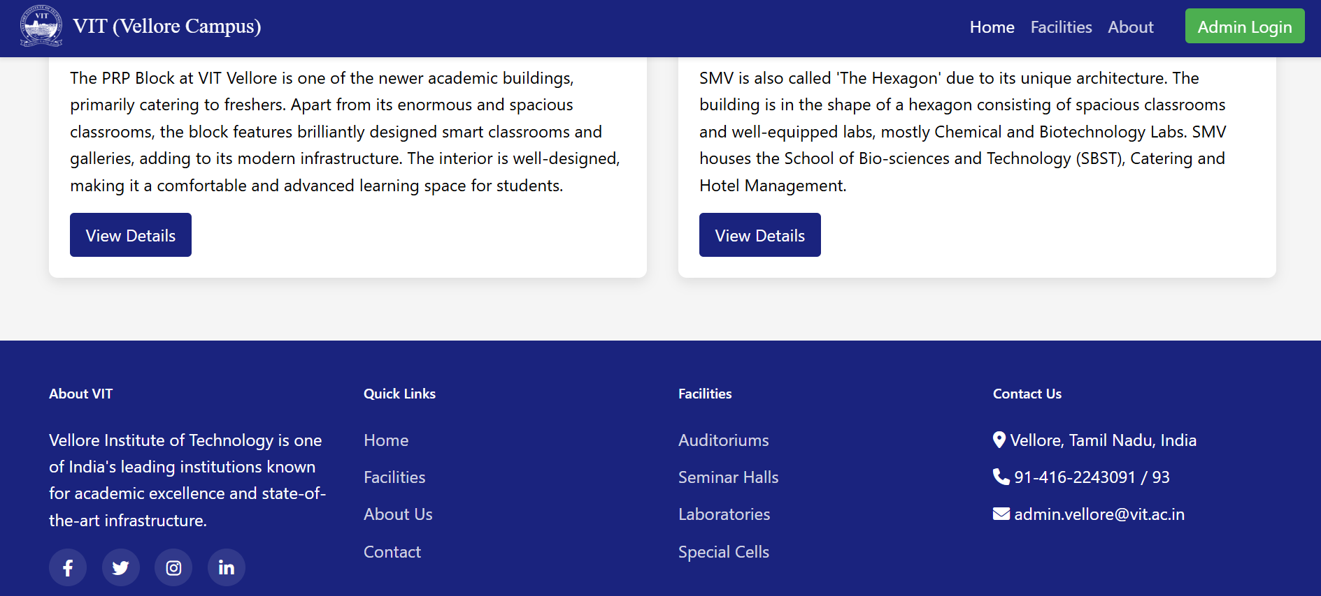

**2)You can also click on view details of each tower and on clicking you will be redirected to its new page which contains the information about the block/building.**

FOR TT:

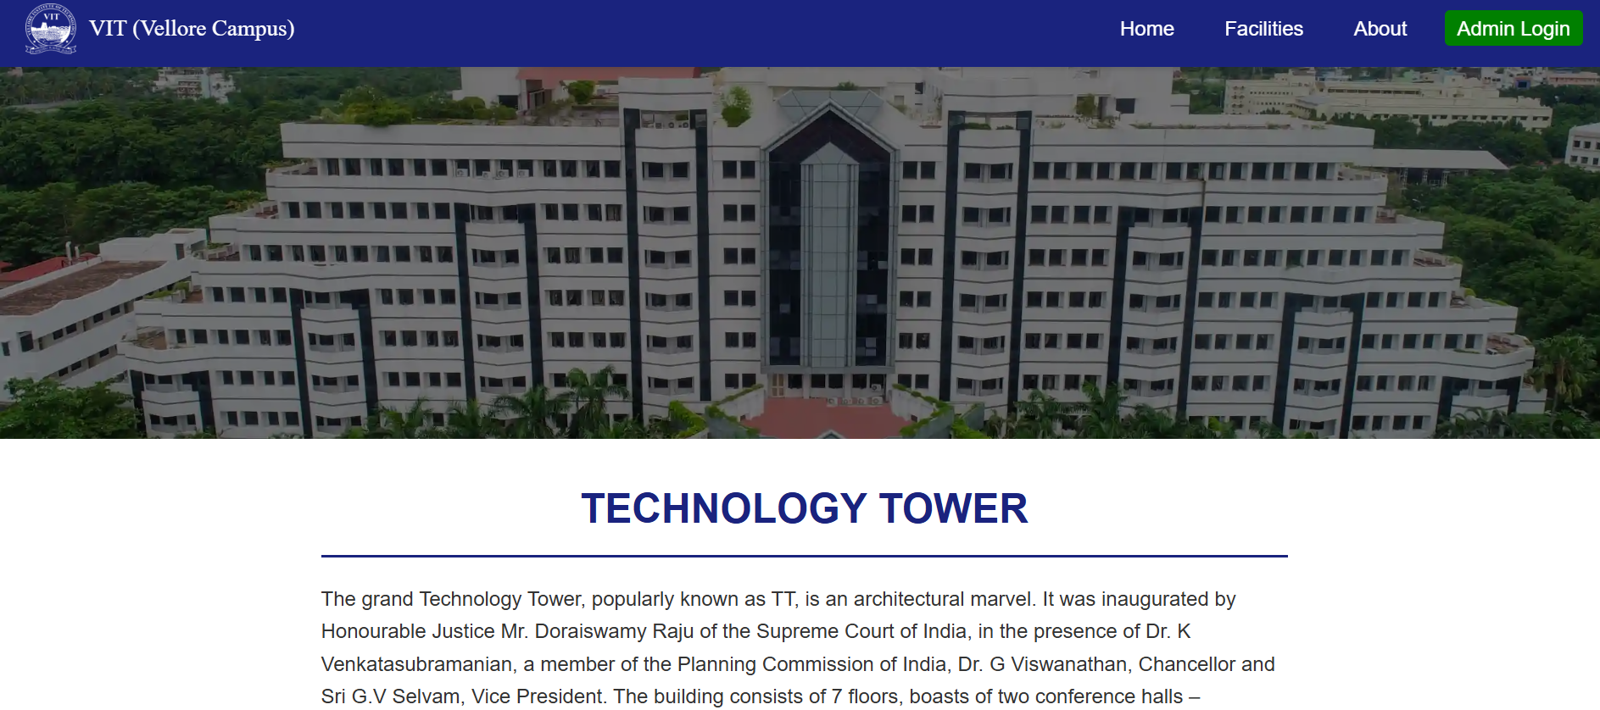

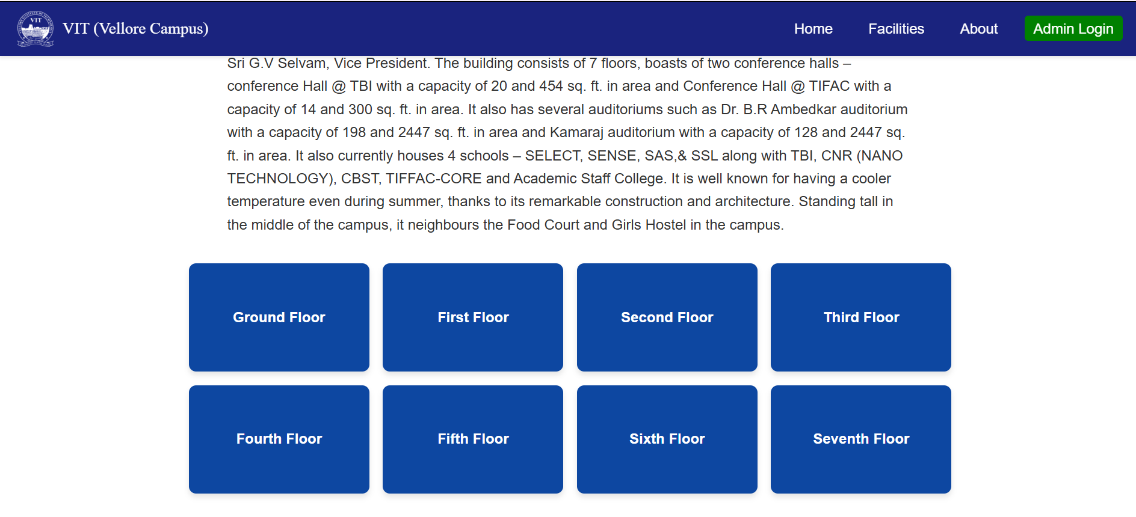

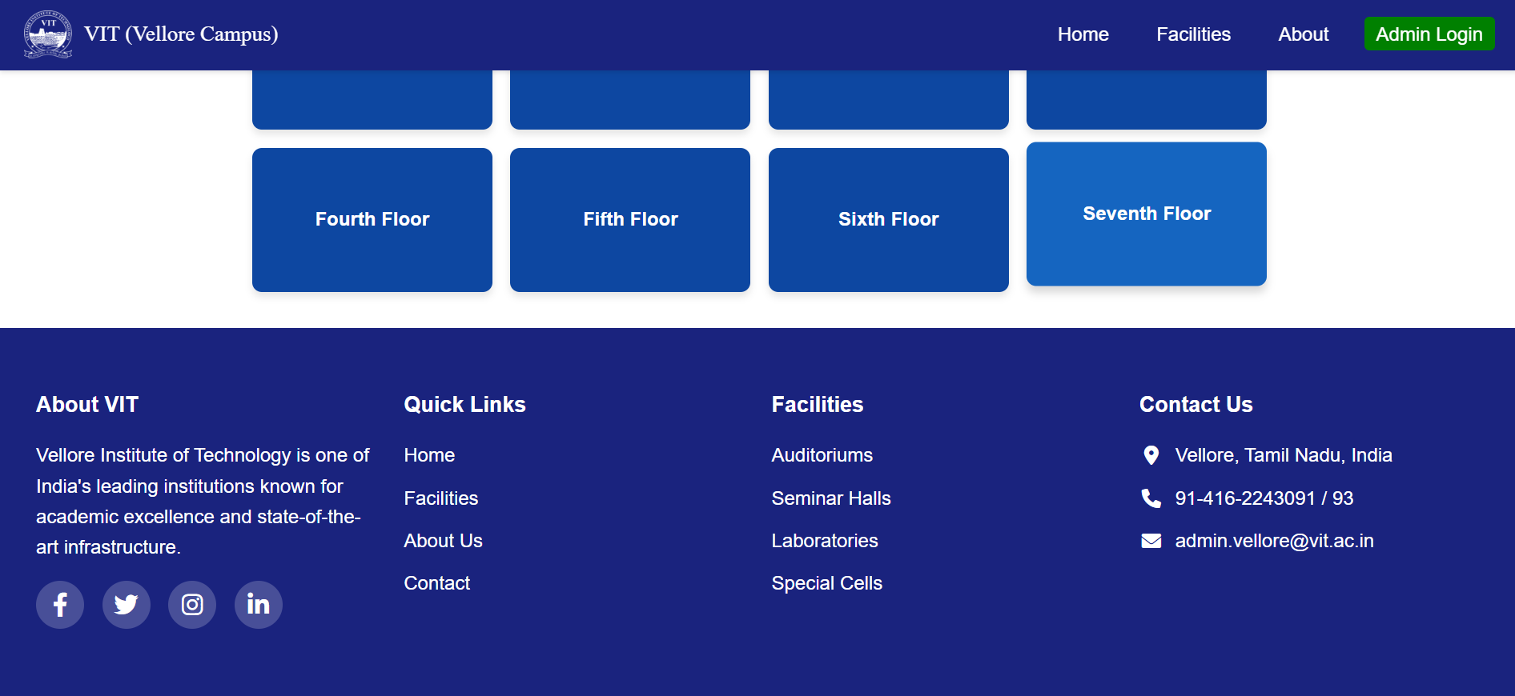

FOR SJT:

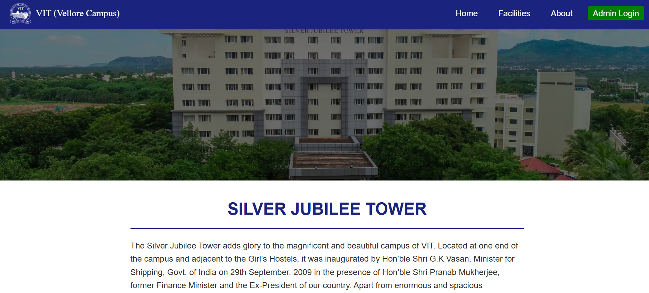

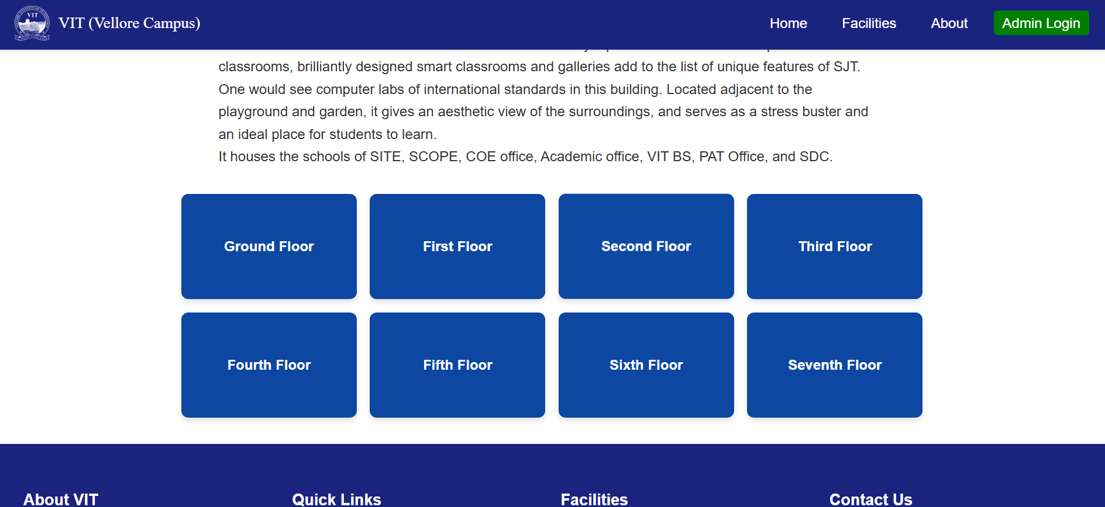

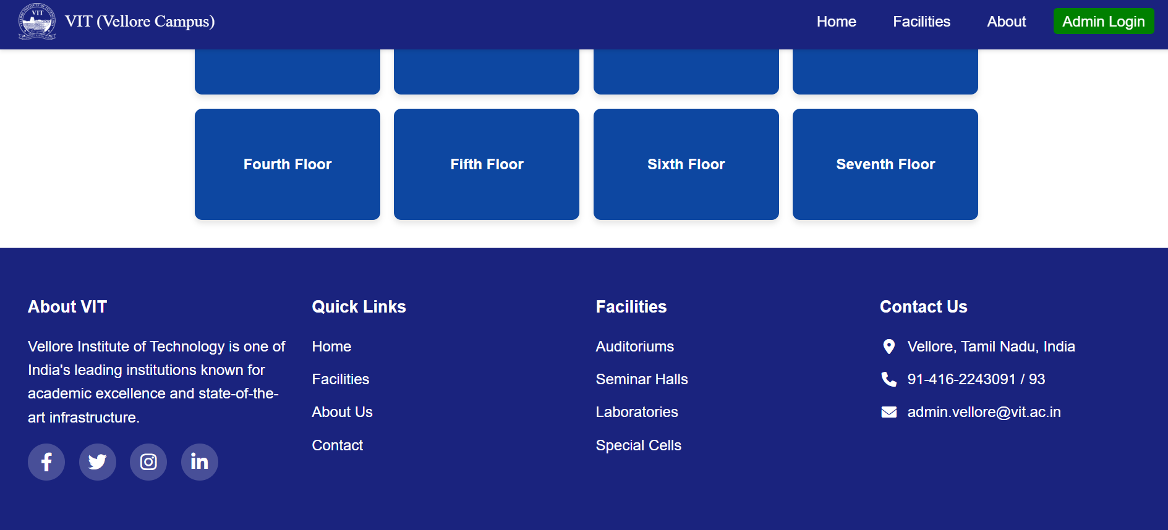

FOR PRP:

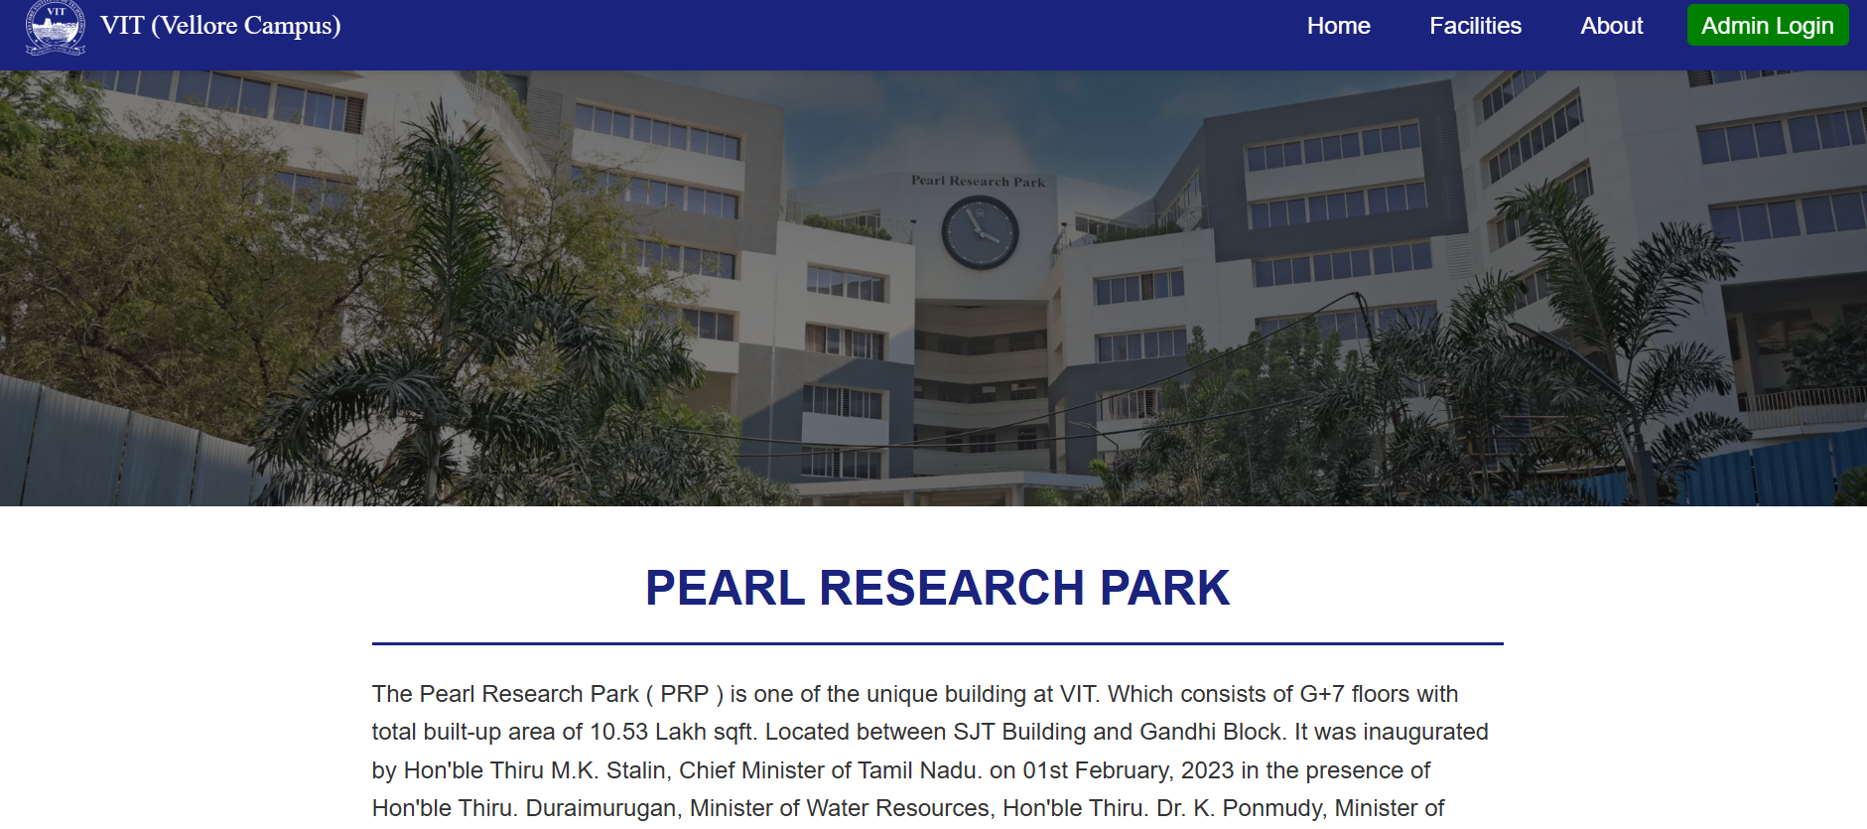

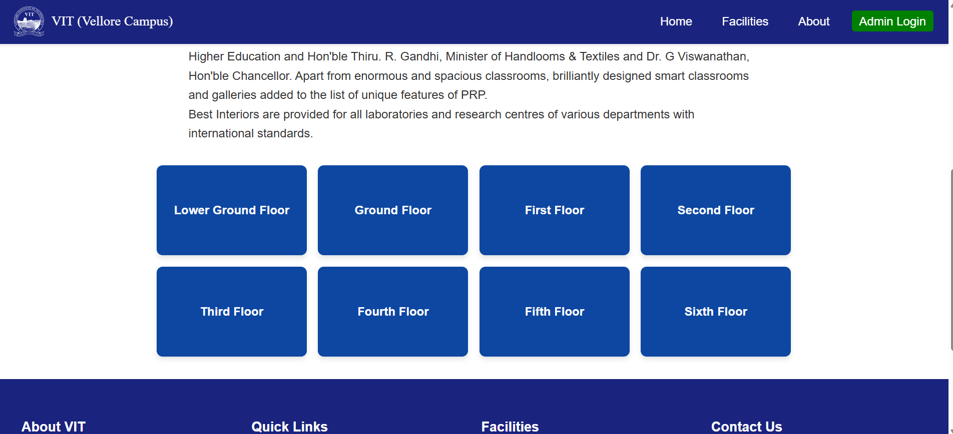

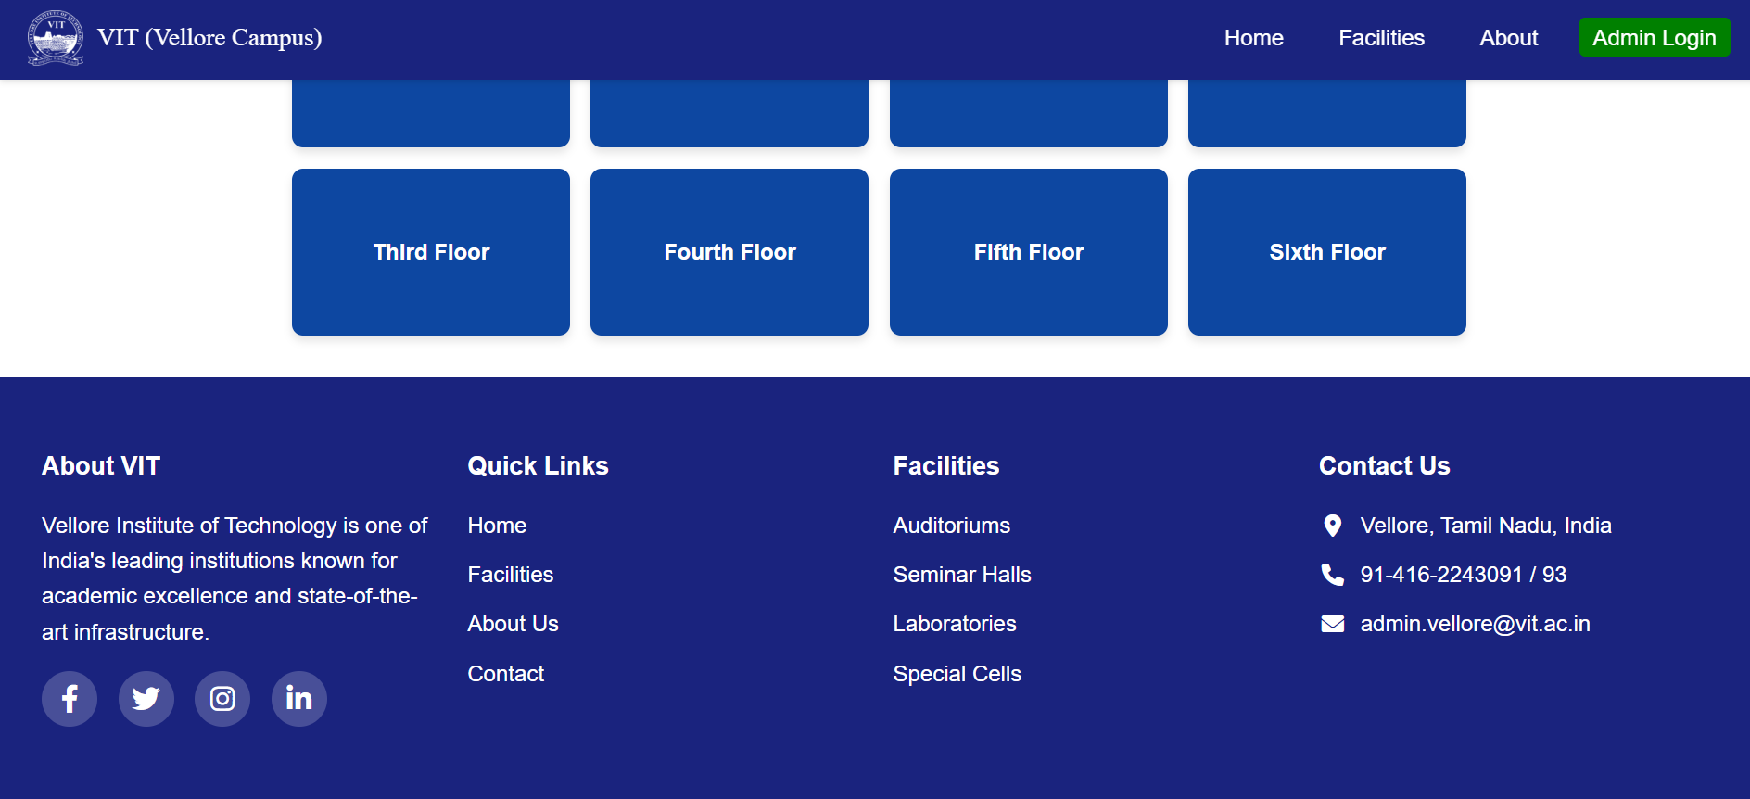

FOR SMV:

**3)You can also hover over the linkedin,facebook,instagram,twitter logo and you will be redirected to the vit accounts.**

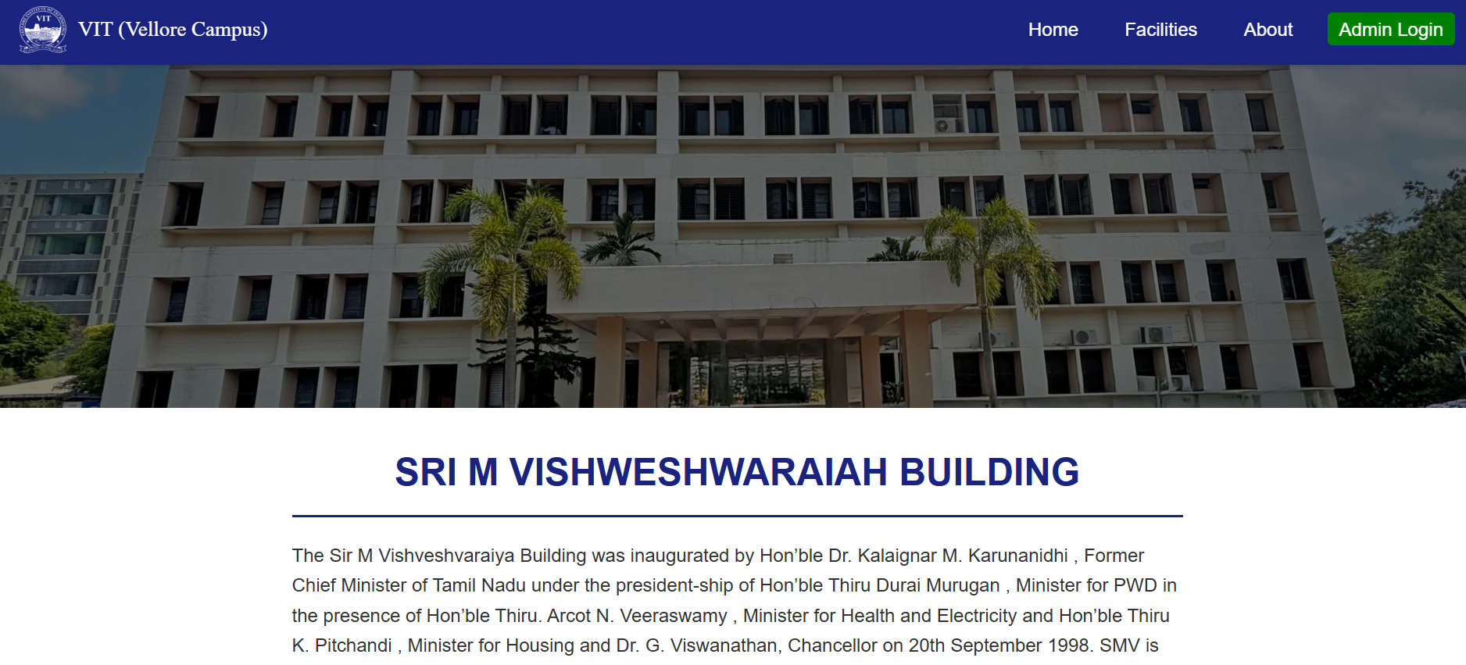

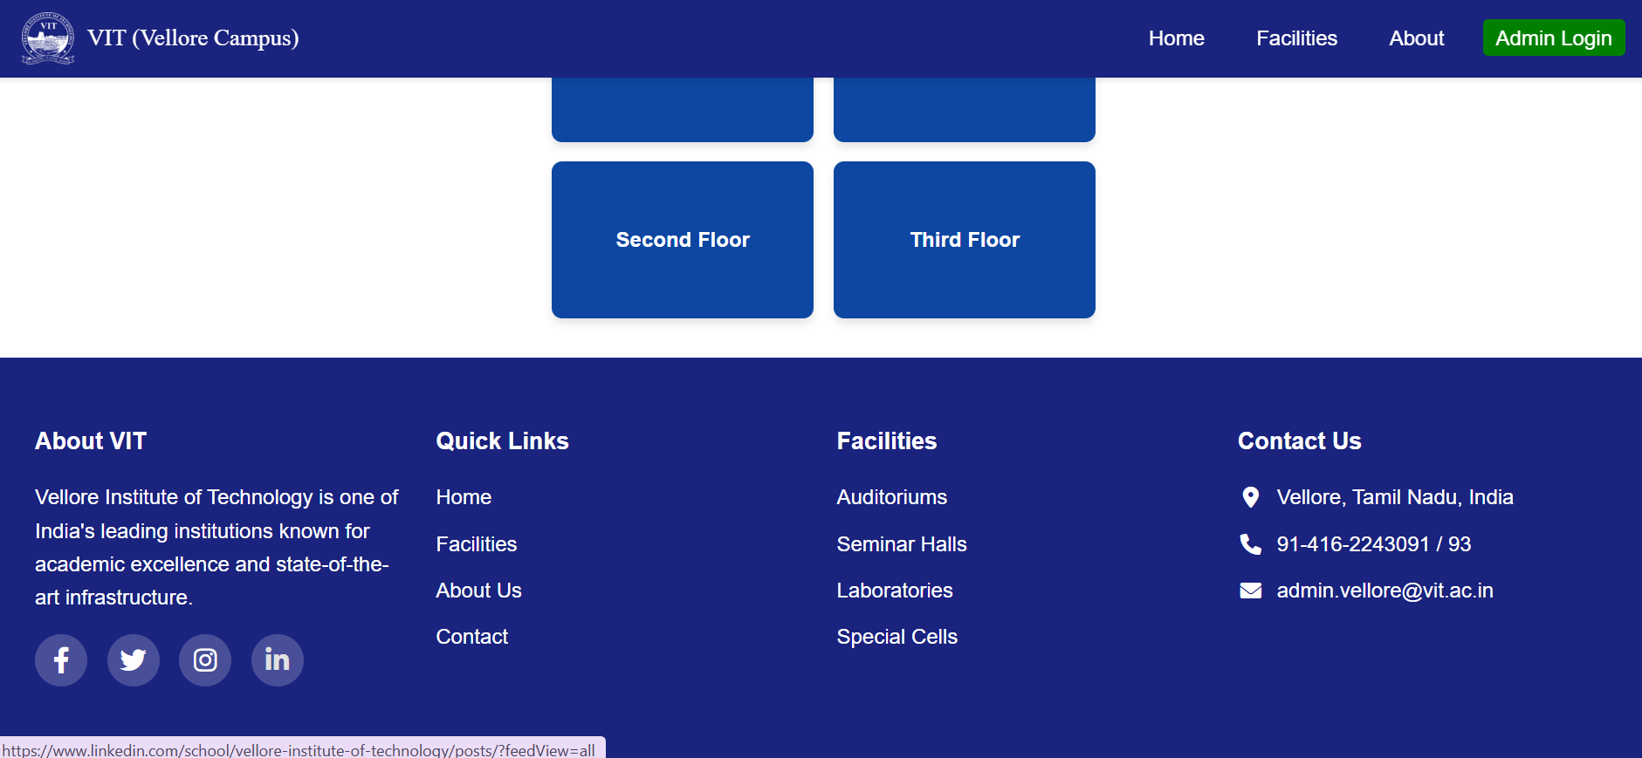

On clicking on likedin logo you will be redirected.

